Lesson 4.1: The Coordinate Plane

Learning objectives for this lesson – By the end of this lesson, you will be able to:
- Identify coordinates of points.
- Plot points in a coordinate plane.
- Graph a function given a table.
- Graph a function given a rule.

California State Standards Addressed: Algebra I (4.0, 5.0, 6.0)
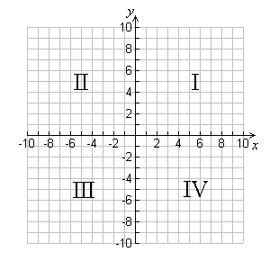
Introduction
We now make our transition from a number line that stretches in only one dimension (left to right) to something that exists in two dimensions. The coordinate plane can be thought of as two number lines that meet at right angles. The horizontal line is called the x–axis and the vertical line is the y–axis. Together the lines are called the axes, and the point at which they cross is called the origin. The axes split the coordinate plane into four quadrants. The fist quadrant (I) contains all the positive numbers from both axes. It is the top right quadrant. The other quadrants are numbered sequentially (II, III, IV) moving counter–clockwise from the first.

4.1.1: Identify coordinates of points.
When given a point on a coordinate plane is a relatively easy task to determine its coordinates. The coordinates of a point are 2 numbers – written together they are called an ordered pair. The numbers describe how far along the x–axis and y–axis the point is. The ordered pair is written in parenthesis, with the x–coordinate (also called the ordinate) first and the y–coordinate (or the abscissa) second:

(1, 7) – an ordered pair with an x–value of 1 and a y–value of 7
(0, 5) – an ordered pair with an x–value of 0 and a y–value of 5
(–2.5, 4) – an ordered pair with an x–value of –2.5 and a y–value of 4
(–107.2, –.005) – an ordered pair with an x–value of 107.2 and a y–value of –0.005

The first thing to do is realize that identifying coordinates is just like reading points on a number line, except that now the points do not actually lie on the number line! Look at the following example:

Example 1
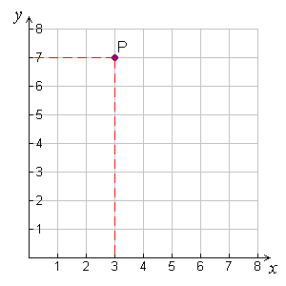
Find the coordinates of the point labeled P in the diagram to the right.
Imagine you are standing at the origin (the points where the x–axis meets the y–axis). In order to move to a position where P was directly above you, you would move 3 units to the right (we say this is in the positive x direction).
The x–coordinate of P is +3.

Now if you were standing at the 3 marker on the x–axis, point P would be 7 units above you (above the axis means it is in the positive y direction).
The y–coordinate of P is +7.

Solution: The coordinates of point P are (3, 7).

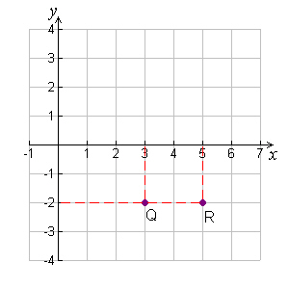
Example 2
Find the coordinates of the points labeled Q and R in the diagram to the right.

In order to get to Q we move 3 units to the right, in the positive–x direction, then 2 units down. This time we are moving in the negative y direction. The x coordinate of Q is +3, the y coordinate of Q is –2.

The coordinates of R are found in a similar way: the x coordinate is +5 (5 units in positive x) and the y–coordinate is again –2.

Solution: Q (3, –2); R(5, –2)

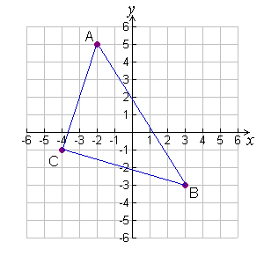
Example 3
Triangle ABC is shown in the diagram to the right. Find the coordinates of the vertices A, B and C.
Point A: x–coordinate = –2
y–coordinate = +5

Point B: x–coordinate = +3
y–coordinate = –3

Point C: x–coordinate = –4
y–coordinate = –1

Solution: A (–2, 5); B (3, –3); C(–4, –1)

04.1.2: Plot points in a coordinate plane.
Plotting points is a simple matter once you understand how to read coordinates and read the scale on a graph. As a note on scale, in the next two examples pay close attention to the labels on the axes.

Example 4
Plot the following points on the coordinate plane:
A (2, 7) B (–5, 6) C (–6, 0) D (–3, –3) E (0, 2) F (7, –5)
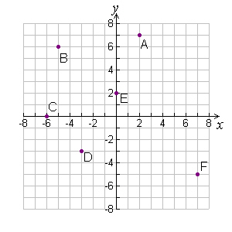
Point A (2, 7) is 2 units right, 7 units up. It is in Quadrant I.

Point B (–5, 6) is 5 units left, 6 units up. It is in Quadrant II.

Point C (–6, 0) is 6 units left, 0 units up. It is on the x axis.

Point D (–3, –3) is 3 units left, 3 units down. It is in Quadrant III.

Point E (0, 2) is 2 units up from the origin. It is on the y axis.

Point F (7, –5) is 7 units right, 5 units down. It is in Quadrant IV

Example 5
Plot the following points on the coordinate plane:
A (2.5, 0.5) B (π, 1.2) C (2, 1.75) D (0.1, 1.2) E (0, 0)
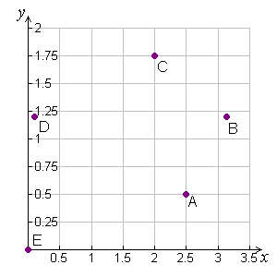
Choice of axes is always important: In example 4 it was important to have all 4 quadrants visible, but in this case all the coordinates are positive. There is no need to show negative values of x or y. Also, there are no x values bigger than about 3.14, and 1.75 is the largest value of y. We will therefore show these points on the following scale {0 ≤ x ≤ 3.5} and {0 ≤ y ≤ 2}. The points are plotted to the right.
Note that points B and D do NOT lie on grid lines – why not?
Some other important points to note about this graph:
- The tick marks on the axes do not correspond to unit increments (i.e. the numbers do not go up by one)
- The scale on the x–axis is different to the scale on the y–axis.
- The scale is chosen to maximize the area that the plotted points cover

04.1.3: Graph a function given a table.
Once we know how to plot points on a coordinate plane, we can think about how we would go about plotting a relationship between x and y values – in other words plot a function. Remember that a function is a particular way to relate one quantity to another. If you read a book and can read 20 pages an hour there is a relationship between how many hours you read, and how many pages you read. You may even know that you could write the formula as either:
n = 20·h n = number of pages; h = time measured in hours. OR…
$h=\frac{n}{\text{20}}$
So you could use the function that related n and h to determine how many pages you could read in 3½ hours, or even to find out how long it took you to read 46 pages.

On a graph a function appears as a line (not necessarily straight) that goes through all points that satisfy the relationship that the function describes.

Example 6
Nadia is thinking of the number of presents she receives as a function of the number of friends who come to her birthday party. She knows she will get a present from her parents, one from her grandparents and one each from her uncle and aunt. She wants to invite up to 5 of her friends, who will each bring one present. She makes a table of how many presents she will get if one, two, three, four or five friends come to the party. Plot the points on a coordinate plane and graph the function that links the number of presents with the number of friends. Use your graph to determine how many presents she would get if 8 friends show up.

Number of friends | Number of presents
0 | 4
1 | 5
2 | 6
3 | 7
4 | 8
5 | 9

The first thing we need to do is decide how our graph should appear: we need to decide what the independent variable is, and what the dependant variable is. Clearly in this case, the number of friends can vary independently, whilst the number of presents must depend on the number of friends who show up.

We will therefore plot friends on the x–axis and presents on the y–axis. Let’s add another column to our table containing the coordinates that each (friends, presents) ordered pair gives us:

no. of friends (x) | no. of presents (y) | coordinates (x, y)
0 | 4 | (0, 4)
1 | 5 | (1, 2)
2 | 6 | (2, 6)
3 | 7 | (3, 7)
4 | 8 | (4, 8)
5 | 9 | (5, 9)

Next we need to set up our axes. It is clear that the number of friends and number of presents both must be positive, so we do not need to worry about anything other than quadrant one. We need to choose a suitable scale for the x and y axes – we need to consider no more than 8 friends (look again at the question to confirm this), but it always pays to allow a little extra room on your graph. We also need the y scale to accommodate the presents for 8 people – we can see that this is still going to be under 20!
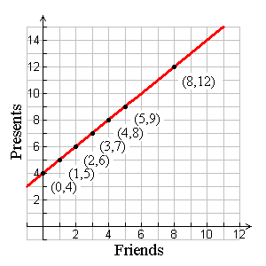
The scale of the graph on the right shows room for up to 12 friends and 15 presents. This will be fine, but there are many other scales that would be equally as good!

Now we proceed to plot the points. The first five points are the coordinates from our table. You can see they all lie in a straight line, so the function that describes the relationship between x and y will be linear. To graph the function, we simply draw a line that goes through all five points. This line represents the function.

The graph easily lets us find other values for the function. For example, the question asks how many presents Nadia would get if 8 friends come to her party. Don’t forget that x represents the number of friends and y represents the number of presents. If we look at x = 8 we can see that the function has a y value of 12.

Solution: If 8 friends show up, Nadia will receive a total of 12 presents.

04.1.4: Graph a function given a rule.
If we are given a rule instead of a table, we can proceed to graph in one of two ways. We will use the following example to show each.
Example 7
Peter is trying to work out a trick that his friend showed him. His friend started by asking him to think of a number. Then double it. Then add five to what he got. Peter has written down a rule to describe the first part of the trick. He is using the letter x to stand for the number he thought of and the letter y to represent the result of applying the rule. His rule is:
y = 2x + 5
Help him visualize what is going on by graphing the function that this rule describes.

Method one – construct a table of values:
If we wish to plot a few points to see what is going on with this function, then the best way is to construct a table and populate it with a few x, y pairs. We will use 0, 1, 2 and 3 for x values:
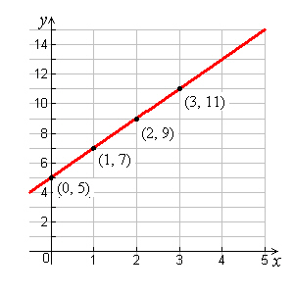
x | y
0 | 2·0 + 5 = 0 + 5 = 5
1 | 2·1+ 5 = 2 + 5 = 7
2 | 2·2 + 5 = 4 + 5 = 9
3 | 2·3 + 5 = 6 + 5 = 11

Next we plot the points and join them with our line:
This method is nice and simple – plus, with linear relationships
there is no need to plot more than two or three points.

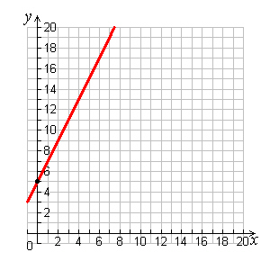
Method two – Intercept and slope
1
2
One other way to graph thus function (and one that we will learn in more detail in the next lesson) is the slope–intercept method. To do this, follow the following steps:
- Find the y value when x = 0:
y(0) = 2·0 + 5 = 5 – So our y–intercept is (0, 5)
- Look at the coefficient multiplying the x:
Every time we increase x by 1, y increases by 2 so our slope is +2
- Plot the line with the given slope that goes through the intercept. We start at the point (0, 5) and move over 1 in the x direction, then up 2 in the y direction. This gives the slope for our line, which we extend in both directions.

We will properly examine this last method in the next lesson!
Homework Problems:
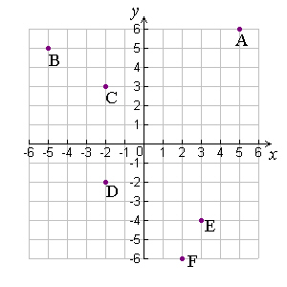
- Identify the coordinates of each point, A – F, on the graph to the right.

- Plot the following points on a graph and identify which quadrant each point lies in:
  - (4, 2) b. (–3, 5.5) c. (4, –4) d. (–2, –3)

- The following 3 points are 3 vertices of square ABCD. Plot them on a graph then determine what the coordinates of the fourth point, D, would be. Plot that point and label it.
A (–4, –4) B (3, –4) C (3, 3)

- Nadia has a large bag of M&Ms that she knows she should share with Peter. Peter, meanwhile has a packet of Starburst. Nadia tells Peter that for every Starburst he gives her, she will give him 3 M&Ms in return. If x is the number of Starburst that Peter gives Nadia, and y is the number of M&Ms he gets in return:
  - Write an algebraic rule for y in terms of x

  - Make a table of values for y with x values of 0, 1, 2, 3, 4, 5.

  - Plot the function linking x and y on the following scale: {0 ≤ x ≤ 10}, {0 ≤ y ≤10}

Answers:
- A (5, 6); B (–5, 5); C (–2, 3); D (–2, –2); E(3, –4); F(2, –6)
2. a. Quadrant I;  b. Quadrant II;  c. Quadrant IV;  d. Quadrant III  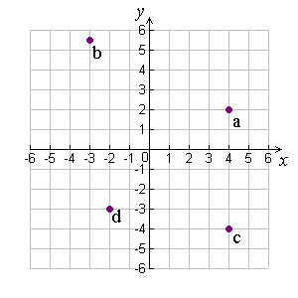 | 3.  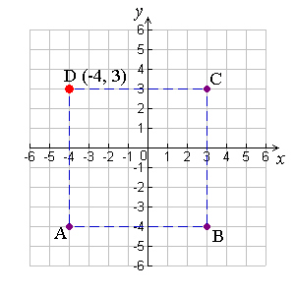 | 4 a. y = 3x  b. | c.  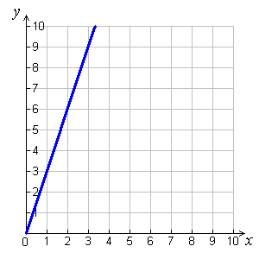
  x | y
  0 | 0
  1 | 3
  2 | 6
  3 | 9
  4 | 12
  5 | 15

